**Ex No 2**

**Run a basic Word Count Map Reduce program to understand Map Reduce Paradigm.**

**AIM:**

To run a basic Word Count MapReduce program using Hadoop.

**PROCEDURE:**

**Step 1: Start the Hadoop cluster** 1. Open Terminal in administrative mode:

○ Open a terminal window.

○ Run Hadoop's startup scripts to start the cluster:

cd /usr/local/Cellar/hadoop/3.4.0/libexec/sbin

./start-dfs.sh

./start-yarn.sh

2. Verify that all nodes are up by running: jps

**Step 2: Create an input directory in HDFS**

Create an HDFS directory where you will place the input file for the MapReduce job. You can name it "input_dir":

hadoop fs -mkdir /input_dir

**Step 3: Copy the input text file to the input directory**

Prepare your input file (named input_file.txt), or create a sample text file on your local system:

echo "Hadoop is a distributed computing framework" > ~/input_file.txt

Copy the input file to HDFS:

hadoop fs -put ~/input_file.txt /input_dir

**Step 4: Verify if the file is copied to HDFS** List files in the input directory:

hadoop fs -ls /input_dir

Check the content of the copied file:

hadoop fs -cat /input_dir/input_file.txt

**Step 5: Run the MapReduce Word Count job**

1. Run the MapReduce job:

○ Use the built-in WordCount example that comes with Hadoop.

○ Run the following command, specifying the input directory (/input_dir) and an output directory (/output_dir):

hadoop jar

/usr/local/Cellar/hadoop/3.4.0/libexec/share/hadoop/mapreduce/ha doop-mapreduce-examples-3.4.0.jar wordcount /input_dir /output_dir

**Step 6: Verify the output generated**

Check the content of the output directory:

hadoop fs -ls /output_dir

View the content of the output file:

hadoop fs -cat /output_dir/part-r-00000

**Step 7: Useful Hadoop Commands** To delete a file from HDFS directory: hadoop fs -rm -r /input_dir/input_file.txt

To delete a directory from HDFS directory: hadoop fs -rm -r /input_dir

**Output:**

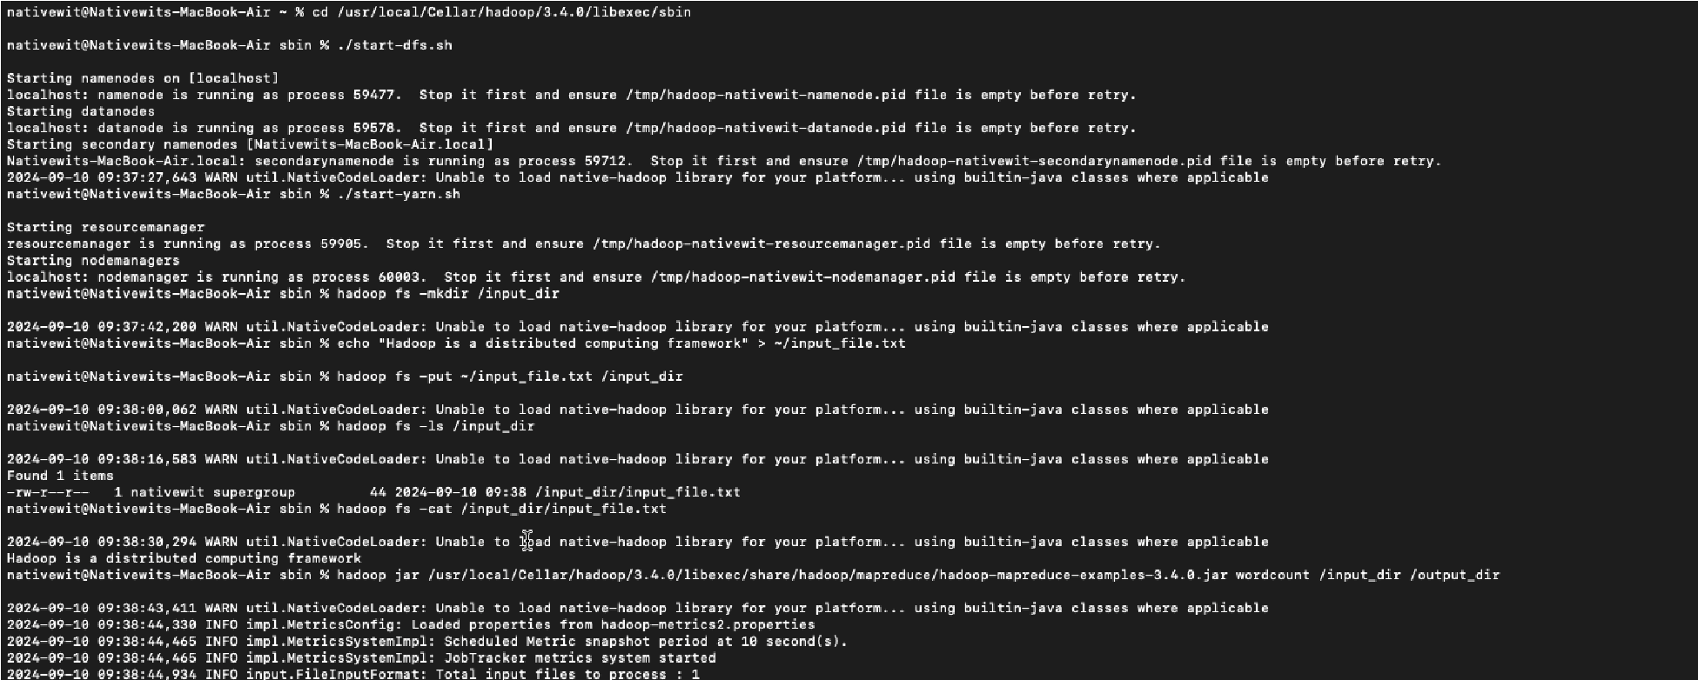

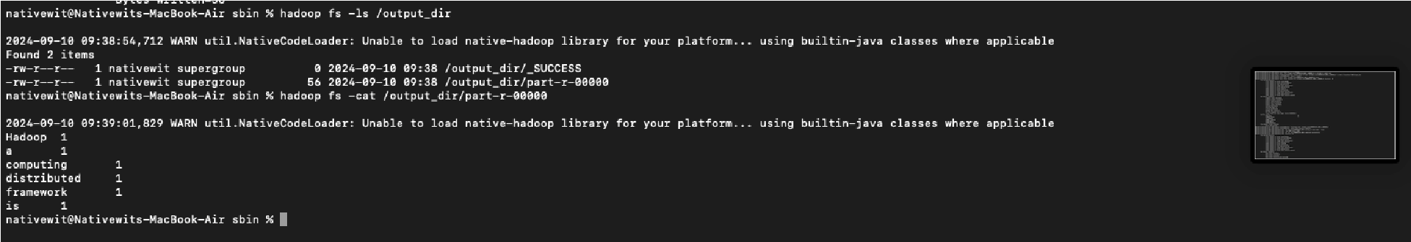

**RESULT:**

Thus, the program for basic Word Count Map Reduce has been executed successfully.